International Journal of Electronics & Informatics |  | ORIGINAL ARTICLE
Template for International Journal of Electronics & Informatics
Authors Name, Not Affiliation
ISSN: 2186-0114  http://www.IJEI.org  ARTICLE HISTORY  Received:  Revised: 1  Accepted:  Published online: | Abstract  Write short abstract within 250 words. Bookman Old Style, Font size 9, Italic. Please use this document as a template, using MSWord (save the files in *.docx format). Follow the information below. The paper length can be 6~10 pages. If the paper is NOT according to this Template – it may NOT be published in the journal. Attach *docx and PDF format when you submit the Final paper once the paper is accepted. Visit website for policies. You must sign the copyright form for the publisher of IJEI once the paper is accepted. Mention 3~5 keywords.  Keywords: IJEI, template, electronics, informatics, reference.  © Center for Natural Sciences & Engineering Research (CNSER), IJEI.  All rights reserved.

Introduction
WELCOME to the journal. Please work in A4 sized paper and save to MS Word template directory. For more information, please visit our website.
Bookman Old Style, Font size 10, normal. Try to avoid Underline or Bold within texts.
This section should provide enough background information to make it clear why the study was undertaken and should clearly describe the objectives of the study.

Related Works and Methods
This section should provide the reader with all the information necessary to repeat the work. For a modification of published methodology, only the modification needs to be described, with reference to the original source. Statistical analysis of the data (where applicable) is mandatory, using appropriate methods, which must be cited.

Title page – Sub-section – Font size 9
A separate title page should be added before the main document. Add following information in the title page:
- Title
- Short Title
- Authors name and affiliations
- E-mail address of all authors
- Corresponding author: Clearly indicate who will handle correspondence at all stages of refereeing, publication and post-publication. Ensure that telephone and fax numbers (with country and area code) are provided in addition to the e-mail address and the complete postal address.

Preparation of the main document
Manuscripts should be prepared in A4 sized paper and save to MS Word (*.docx) directory. Use a proportional font Bookman old style in normal, 10-point size. The entire text should be single-spaced with appropriate margins. The use of footnotes to the text should be avoided. Sentences should be separated by a single space. For spelling, USA style is preferred. Common Latin abbreviations such as ibid., etc., e.g., i.e., and ‘et al.’, and short, commonly used Latin terms such as ‘in vitro’, ‘in vivo’, and ‘in situ’, should NOT be italicized.

Length of Manuscript
The manuscript should be within 6~10 pages. For detail see the website.

Organisation of main document

The preferred organisation of the Main Document of an original paper is as follows:

Title

Authors name and affiliation

Abstract, Key words and short title

Introduction
- Related works & background

Materials and Methods

Results or Results and Discussions

Conclusion

Acknowledgments

References

However, authors are not obliged to adhere rigidly to this organization. They may modify the style when such modification makes the presentation clearer and more effective. There is no restriction on the style of review articles.

Sections and Subsections
The article should divide into clearly defined and numbered sections. Sections should be numbered with roman number (i.e. I., II., III., …) and the subsections should be number with A., B., C., … (then i., ii., iii., …) etc. Use auto-number for sections and subsections.

Figures
Figures should be presented within the text and labeled in consecutive Arabic numerals; also submit original figures as separate file. The final size of figures should be fitted either in 1 column or 2 columns. All lettering should be done using standard font Bookman Old Style, Font size 9, normal.
Figures with several parts should be in proportion, with consistently sized lettering so that the whole figure can be reduced by the same amount to the smallest size at which the essential details are visible.
The following resolutions are optimal: colour or black & white line figures- 600 dpi; photographs- 300 dpi; screen dumps- leave as it is. We encouraged preparing the figures as EPS format; but you can also use high quality BMP or JPG format. Use the abbreviation “Fig.” even at the beginning of a sentence, do not write “Figure” and numbered as “Fig. 1. xxx xxx ” in the caption of the figure. Example:
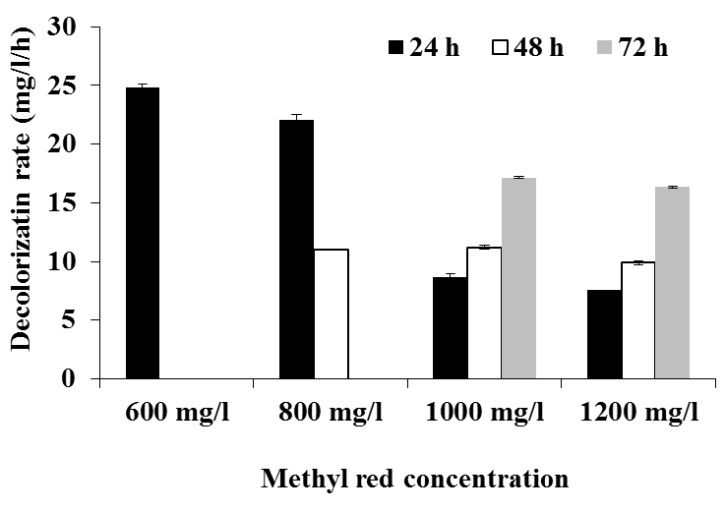
Fig. 1. The Figure needs proper title and information to understand.

Tables
Tables should be typed in separate sheet as text (not as picture), numbered consecutively with Arabic numerals (1, 2, 3) and fitted either in 1 column or 2 columns.
All lettering should be done using standard fonts, Bookman Old Style, Font size 9, normal.
Tables should be self-explanatory and include a brief descriptive title. Footnotes to tables indicated by lower-case superscript letters are acceptable, but they should not include extensive experimental detail.
Number tables as “TABLE I. xxx xxx”. Don not abbreviate table as “Tab.”.
Example:
TABLE I. Table should be as text, not as image format. Need to provide proper title.
Litterfall | 1st year | 2nd year
Leaf | 610.05±9.54 | 657.26±13.17
Stipule | 104.33±1.76 | 111.06±2.24
Flower bud | 8.82±0.29 | 12.34±0.37
Total | 935.73±16.68 | 1321.9±31.20

*Mean value (g m⁻² yr⁻¹) is shown with its SE.

Units
Use either SI (MKS) or CGS as primary units. (SI units are strongly encouraged.)

Reference and citations
Number the citations consecutively in square brackets [1] within the text. The sentence punctuation follows the brackets [2]. Multiple references are each numbered with a single bracket [1–3]. When citing a section in a book, please give the relevant page numbers [2]. In sentences, refer simply to the reference number, as in [3]. Do not use “Ref. [3]” or “reference [3]” except at the beginning of a sentence: “Reference [3] shows ... .”
Try to avoid footnotes.
For the reference style please see the Reference Section below.

Equations
Number equations consecutively with equation numbers in parentheses, as in

… … … … … (1)
Refer to “(1),” not “Eq. (1)” or “equation (1),” except at the beginning of a sentence: like “Equation (1) is ... .” An equation must not be as image.

Language Check
If your native language is not English and if you feel that you need to go-though, please get a native English-speaking colleague to proofread your paper!

Results
Results should be clear and concise.

Discussions
This should explore the significance of the results of the work, not repeat them. Author can write the Results and Discussion section in combined.

Conclusions
The main conclusions of the research may be presented in a short Conclusions section. It is highly recommended that you add Future Work issues in this section.

Acknowledgments
Write acknowledgements in a separate section at the end of the article before the references, if any. List here those individuals who provided help during the research.

References
Reference should be written with standard font Bookman old style in normal, 9-point size; number as [1], [2], … and use auto-number, that is shown in below and also follow the detailed instruction of referencing presented below.
Reference style that should be presented in the main document:
- A. B. Doong, C. Aaaaa, and P. Bbbbb, “For a chapter in a book,” in Image Processing, 4th ed. vol. 2, J. Peters, Ed. New York: Publisher’s Name, Year, pp. 11–60.
- H. Author and B. B. Bbbbb, A Book. New York: Publisher, Yr, Vol. 1, ch. 3.
- B. Annnn, “Unpublished work so far,” unpublished.
- A. Ahaan, “Journal paper title,” Intl. Journal of Computer Vision & Signal Processing, Vol. 1, No. 2, 1987, pp. 23-49.
- A. F. Ruruu, “Conference proceedings,” in Proc. of IEEE Intl. Conf. on Informatics, Electronics & Vision (ICIEV), 2012, Dhaka, Bangladesh, pp. 8-13.
- A. Authors, “OnlineInfo – Title of the article,” [Online]. Accessed on June 2012, Available: http://iciev.org

Details to write the reference:
Note on online sources:
• If no publication date is given write (No date).
• Date of publication is the date the pages were last updated.
• The accessed date is when you viewed, downloaded or printed the Web page.
• The term publisher is used here to cover both the traditional idea of publisher of printed sources, as well as organizations responsible for maintaining sites on the Internet, such as the Kyushu University.
• Often information is put on the Internet by organizations without citing a specific author. In such cases, ascribe authorship to the smallest identifiable organizational unit or start with the title.

AUTHORS INFO Author 1* e-mail: Address: Author 2 e-mail: Address: Author 3 e-mail: Address: *Corresponding author e-mail: mahinmicro@yahoo.com Tel: ; Fax:

